Lan Yu Sørensen
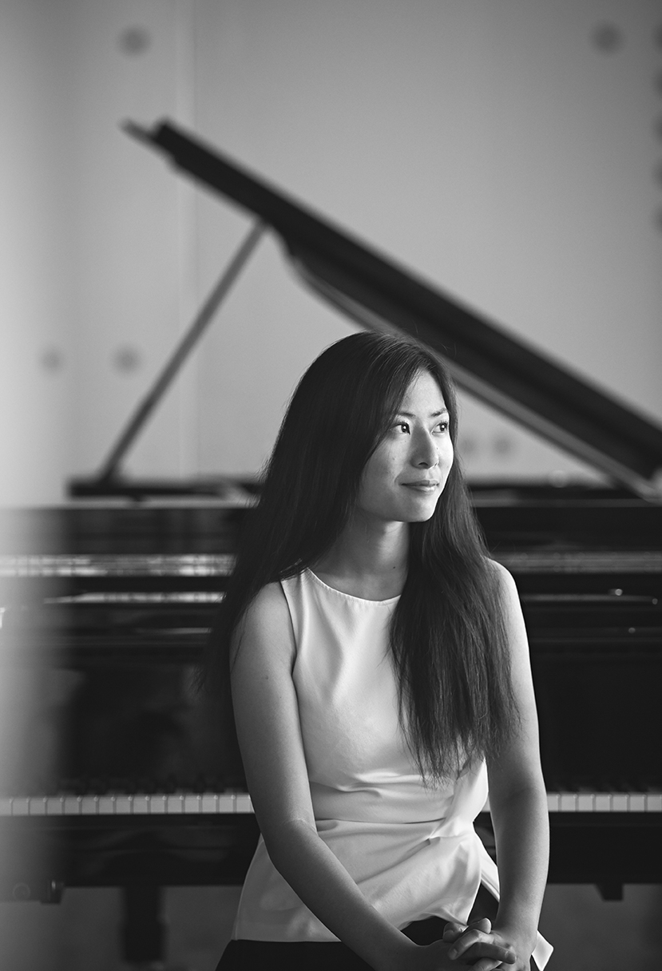
Lan Yu is born 3rd of February 1996 in Tianjin, China, but moved to Denmark when she was 8 years old. She entered the Royal Academy of Music, Aarhus in 2014, where she started her studies with professor Anne Øland (2014-15) and since with Søren Rastogi, Jakob Bahr and Martin Lysholm. Lan Yu completed her bachelor degree in 2017. In the following school year, she was an exchange student at Sibelius Academy, where she was the youngest masters student. Here she studied with professor Erik T. Tawaststjerna and Hamsa Juris. Lan Yu finished her Master from the Royal Academy of Music, Aarhus in June 2019. She is studying now at the National Danish Academy of Music in Odense with Christina Bjørkøe.

Scholarships and prizes
Over the years, Lan Yu has received a number of generous scholarships, among these from Arthur Andersson og hustru pianistinde Ellen Andersens legat, Knud Højgaard, Holger Arndts Mindefond and Foundation Idella. In addition to that, she has also received “Musikskolens Venners” scholarship 3 times (2008, 2010, 2014).

Lan Yu has been awarded with several prizes in competitions, such as 1st prize at ”den 24. Danske Steinway Konkurrence” in 2014 and in ”Berlingske Tidendes Klassiske Musikkonkurrence” i 2011. Apart from that, she has taken part in EPTA’s “Gradsprøver” (tests for piano) and passed grade 2-7 with high points in all disciplines.

Masterclasses and concerts
As a concert pianist, it has been a priority for Lan Yu to take part in master classes with top professional pianists in order to get inspiration for her own interpretation. She has been playing for Maciej Ganski (Poland), Werner Bärtschi (Swiss), Jószef Balog (Hungary), Katrine Gislinge (Denmark), Julia Dahlkvist (Sweden), Marianna Shirinyan (Oslo), Teppo Koivisto (Helsinki), Bernd Goeztke (Hannover), Alexandre Zvirblyte (Vilnius), Bjørn Lehmann (Berlin), Eugen Indjic (Paris) and Irina Osipova (Moskva).

Lan Yu has also taken part in many concerts and festivals such as OPUS Piano Festival (2011-18) and “Musikskolernes Dag” in Tivoli (2009-2014). She has given solo and chamber music concerts at home and aboard, including USA, Norway, Sweden and Finland.

Teaching experience
Lan Yu has a passion for teaching. She has strong pedagogy training from the Royal Academy of Music, Aarhus and Sibelius Academy, where she has been teaching regularly individual pupils but also in groups. Today, Lan Yu is working as a piano teacher at Rebild Kulturskole, where she is also teaching the talent- and pre-talent groups in ear training and music theory. She has also taken the “Basis 1 course” from Legende Musikteori (the Danish version of Music Mind Games)

In connection with her bachelor project about efficient practice, she has been coaching two bachelor students from the Royal Academy of Music, Aarhus with their daily practice. Also, during her masters project, she has been coach a group of pianists from the academy in a period towards a concert.

Management experience
In connection with her job as a music teacher, Lan Yu has been recommended and completed a course in leadership, ”Nysgerrig på ledelse – et afklaringsforløb".

Besides her studies, Lan Yu has been the deputy chairman for the piano organization, Pianorama in 2016-17. She has also been in charge of the PR at Pianorama’s facebook page and writing the newsletters from 2015-17. In addition to that, she has been employed at Chinese coordinator and mentor at the Royal Academy of Music, Aarhus during 2016-19, at the same time as her office job as library assistant.

In connection with Aarhus International Piano Competition, she has been lecturing at different schools in Aarhus and the neighbourhood about classical music for pupils from 2nd to 5th grade. She was also a part of the co-organizer team at OPUS Piano Festival from 2014-18.

Publications and language skills
Lan Yu has published her book, “The unwritten rules in the world of music” (only in Danish) in June 2022 – a guide for teachers, music school principals, parents and students about all the topics we have to know as a person in the music field.

In May 2020, she published her other book “The way to practice efficiently” (only in Danish) – a step by step guider to help musicians reflect and find a more optimal way of practicing. Based on this book, she is giving lectures in music schools, MGK etc. in Denmark for students and teachers.

In coordination with the anniversary of Hørsholm music school, Lan Yu has published the CD, “Glimt fra det 20. århundrede” (A glimpse from the 20th Century) in 2013.

Lan Yu a good linguist and speaks fluently Chinese, Danish and English. She has been studying German for 5 years and knows also Swedish and Norwegian.

